**Frontend Development with React.js Project Documentation: GLOBAL NEWS**

**(NAVIGATE THE NEWS LANDSCAPE)**

**1.Introduction:**

**Project Title:** Global News

**Team Members and Roles:**

**Team Leader:** Jayashree R (Email: [sac2225cap17@ssacollegechennai.com](mailto:sac2225cap17@ssacollegechennai.com))

**Role**: Project coordinator, ensuring everything runs smoothly and on track.

**Teammate 1**: Kavitha R (Email: [sac2225cap19@ssacollegechennai.com](mailto:sac2225cap19@ssacollegechennai.com))

**Role**: Expertise in UI/UX design

**Teammate 2**: Kaviya V (Email: [kaviyavijayakumar118@gmail.com](mailto:kaviyavijayakumar118@gmail.com))

**Role**: Handling the app's backend

**Teammate 3**: Jeevitha V (Email: [jeeviasha5@gmail.com](mailto:jeeviasha5@gmail.com))

**Role**: Research and content specialist

Global News: Navigate then News is an innovative platform designed to guide users through a rich journey of understanding and awareness. It starts with Navigate, offering an intuitive exploration of key trends, strategies, and insights across various sectors. Once you've charted your course, News takes you to the latest developments and updates, ensuring you remain at the forefront of what's happening in real-time.

**Description:**

* Welcome to the forefront of news discovery with Global News! Our innovative web application is carefully designed to push the limits of traditional news consumption, catering to a wide array of interests from passionate news followers to expert information professionals. With a focus on an intuitive interface, real-time updates, and powerful features like personalized recommendations. The platform also provides easy access to diverse multimedia content, allowing users to not only read but also watch and interact with the news as it unfolds.
* Built with a commitment to an elegant and user-friendly design, Global News offers an immersive journalistic journey. Effortlessly navigate through an expansive range of news topics with tools like dynamic search, tailored filters, and trending stories, bringing the latest and most pertinent stories from around the globe directly to you.

**2. PROJECT OVERVIEW:**

**Project Goals and Objectives:**

The primary goal of Insight Stream is to create an intuitive and accessible platform designed for individuals who are passionate about staying informed, discovering a wide range of news topics, and receiving real-time updates.

The key objectives of the project are as follows:

* **Enhanced User Experience:** Build an interface that is straightforward and user-centric, ensuring that users can easily access, save, and share articles that align with their interests. The platform should be designed with usability in mind, offering seamless navigation and interaction.
* **Comprehensive News Organization:** Develop robust features for efficient content management, allowing users to organize news based on their preferences. The platform will include sophisticated search functionality to deliver a personalized and tailored news consumption experience.
* **Technology Stack:** Employ cutting-edge web development technologies, such as React.js, to ensure an efficient and enjoyable user interface

**Key Features of Global News:**

* **Extensive News Coverage from API Sources** – Gain access to a comprehensive collection of global news, spanning diverse categories and topics to ensure well-rounded and up-to-date information.
* **Engaging Visual News Experience** – Stay informed with a visually enriched news exploration, featuring curated image galleries that enhance the discovery of trending and breaking stories.
* **Powerful Search Functionality** – Effortlessly find news on specific subjects with an advanced search tool that delivers personalized and relevant content based on user preferences.

**3. ARCHITECTURE:**

**Technical Architecture:**

**The user journey begins with the Global News web application’s interface, which is likely developed using a modern framework like React or Vue.js to ensure a seamless, single-page application experience. The UI communicates with an API client built specifically for Global News, which manages the interaction with the backend. What sets it apart is the integration of Rapid API, a platform that connects to a wide range of external APIs. Global News isn’t just another news app it is whole new way to get connected.**

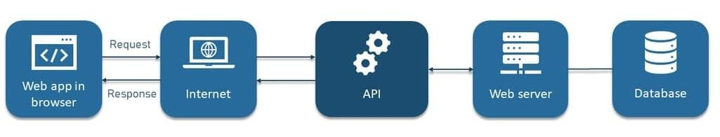

**Component Structure:**

**The application follows a modular component-based architecture in React.js. The key components are:**

* **Navbar Component: Handles site-wide navigation.**
* **Hero Component: Displays top trending news.**
* **Category Components: Fetch and display news under different topics.**
* **NewsArticle Component: Presents individual news articles with title, description, and images.**
* **Search Component: Allows users to search for specific news.**
* **Footer Component: Provides links to social media and other site sections.**

**These components interact via props and state, ensuring a dynamic and responsive interface.**

**State Management:**

* **Global State: Managed using React Context API, enabling centralized state sharing across components.**
* **Local State: Managed using useState and useEffect hooks within individual components.**

**Routing:**

**The app uses React Router to handle page navigation:**

* **Home ("/"): Displays trending news and popular categories.**
* **Category Page ("/category/:id"): Shows news filtered by category.**
* **Search Results ("/search/:query"): Displays search-based news results.**
* **Article Page ("/article/:id"): Shows the complete news article.**

1. **SETUP INSTRUCTION:**

**Pre-Requisites:**

Here are the key prerequisites for developing a frontend application using React.js:

* **Node.js and npm**: Node.js is a powerful JavaScript runtime environment that allows you to run JavaScript code on the local environment. It provides a scalable and efficient platform for building network applications. Install Node.js and npm on your development machine, as they are required to run JavaScript on the server-side.

● Download: <https://nodejs.org/en/download/>

● Installation instructions: <https://nodejs.org/en/download/package-manager/>

* **React.js**: React.js is a popular JavaScript library for building user interfaces. It enables developers to create interactive and reusable UI components, making it easier to build dynamic and responsive web applications.

**Install React.js, a JavaScript library for building user interfaces**.

● Create a new React app:

npx create-react-app my-react-app

Replace my-react-app with your preferred project name.

● Navigate to the project directory:

cd my-react-app

● Running the React App:

With the React app created, you can now start the development server and see your React application in action.

● Start the development server:

npm start. This command launches the development server, and you can access your React app at <http://localhost:3000> in your web browser.

* **HTML, CSS, and JavaScript:**

Basic knowledge of HTML for creating the structure of your app, CSS for styling, and JavaScript

* **Version Control:**
* Use Git for version control, enabling collaboration and tracking changes throughout the development process. Platforms like GitHub or Bitbucket can host your repository.
* Git: Download and installation instructions can be found at: <https://git-scm.com/downloads>

**Installation:**

* **Development Environment:** Choose a code editor or Integrated Development Environment (IDE) that suits your preferences, such as Visual Studio Code, Sublime Text, or WebStorm.
* Visual Studio Code: Download from <https://code.visualstudio.com/download>
* To install and run the Application Project from google drive:
* **Get the code:** <https://drive.google.com/file/d/1-QEM0y-uPGzgoMN-cR8vyyMoqWmlHUQ8/view?usp=sharing>
* Download the code from the drive link given below
* **Install Dependencies:**

• Navigate into the cloned repository directory and install libraries:

cd news-app-react npm install

* **Access the App:**

• Open your web browser and navigate to <http://localhost:3000>.

• You should see the applications homepage, indicating that the installation and setup were successfully.

You have successfully installed and set up the application on your local machine. You can now proceed with further customization, development, and testing as needed.

**5.PROJECT STRUCTURE FOR A NEWS APPLICATION:**

**Client:**

In this project, we’ve split the files into 4 major folders, Components, Context, Pages and Styles. In the pages folder, we store the files that acts as pages at different URLs in the application. The components folder stores all the files, that returns the small components in the application. The context Api will be coded in the context folder. All the styling css files will be stored in the styles folder.

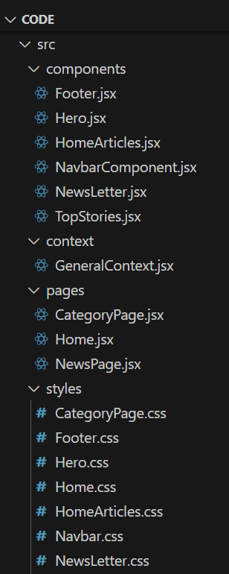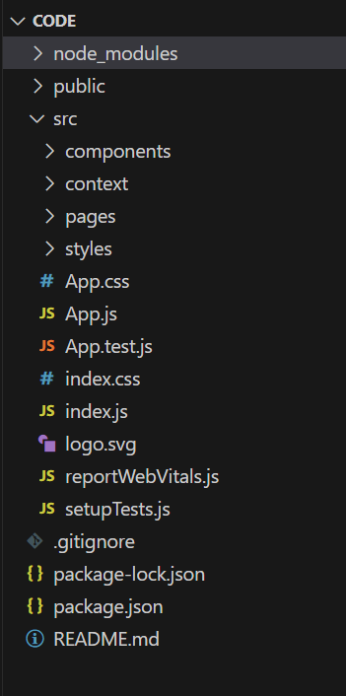

**6.RUNNING THE APPLICATION:**

**Project Flow**

**Project demo:** Before starting to work on this project, let’s see the demo.

Demo link: <https://drive.google.com/file/d/1U3T2iSl06mxz4iRI7HOfNQDWtUZwEwB_/view?usp=sharing>

Use the Code Repository:<https://drive.google.com/file/d/1-QEM0y-uPGzgoMN-cR8vyyMoqWmlHUQ8/view?usp=sharing>

**Milestone 1: Project setup and configuration**.

● **Installation of required tools:**

To build Global News, we'll need a developer's toolkit. We'll use React.js for the interactive interface, React Router Dom for seamless navigation, and Axios to fetch news data. For visual design, we'll choose either Bootstrap or Tailwind CSS for pre-built styles and icons.

Open the project folder to install necessary tools. In this project, we use:

* React Js
* React Router Dom

**Milestone 2: Project Development:**

❖ Setup the Routing paths Setup the clear routing paths to access various files in the application.

❖ Develop the Navbar and Hero components

❖ Code the popular categories components and fetch the categories from newsapi.

❖ Also, add the trending news in the home page.

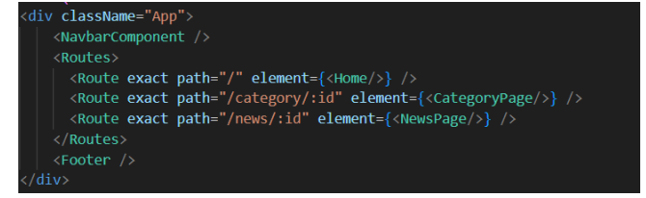

❖ Additionally, we can add the component to subscribe for the newsletter and the footer

❖ Now, develop the category page to display various news articles under the different categories.

**Important Code snips:**

**Fetching Top/Trending news**

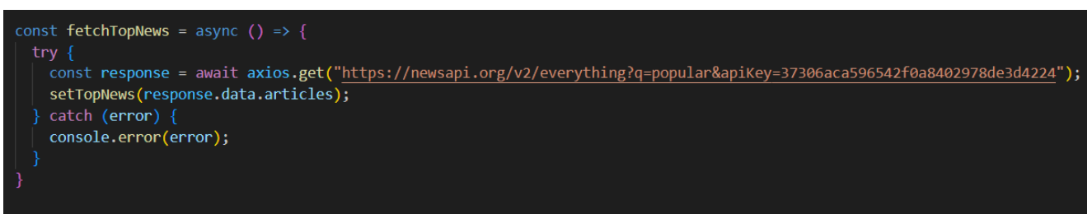With the API request, we fetch the trending news articles.

The code snippet shows a function written in Python called fetchTopNews that fetches news articles from an API.

**Fetching news by search/category**

With the specific category or search keyword, we use API request to fetch all the news articles related to that.

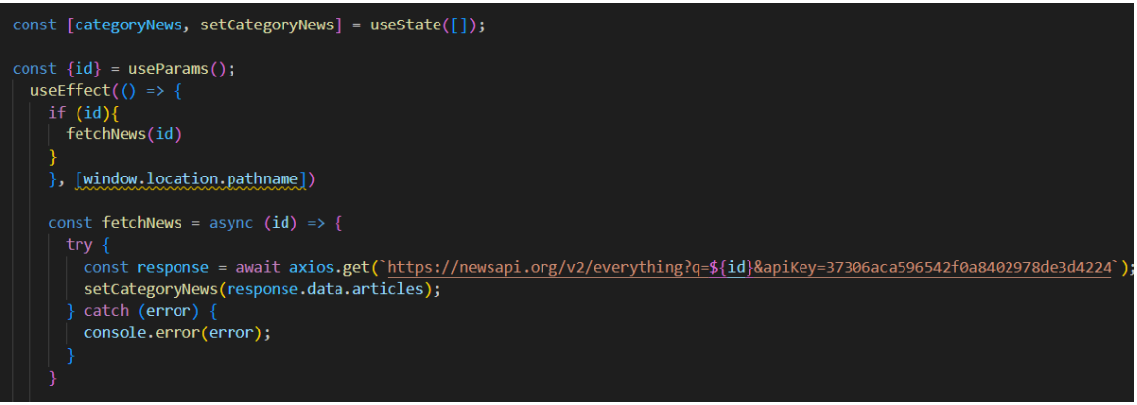

The code snippet shows a function called get_news_articles that fetches news articles from

a news API.

**Building the API Request URL:**

The line url = f'https://newsapi.org/v2/everything?q={query}&apiKey={API_KEY}' constructs the URL for the API request using a formatted string literal (f-string).

The URL includes the following parts:

● Base URL: <https://newsapi.org/v2/everything>

● q: This parameter is set to the query argument passed to the function.

● apiKey: This parameter is set to the API_KEY variable, which should contain the user's API key.

**Making the API Request (requests.get):**

The line response = requests.get(url) sends a GET request to the API URL constructed earlier. The requests.get function from the requests library is used to make the HTTP request. The response from the API is stored in the response variable.

**7.COMPONENT DOCUMENTATION:**

These are the main key components which is used in the Global News app:

* Key Components:

**1.Navbar**

Purpose: Provides navigation links to different categories and search functionality.

Props: categories, onSearch

**2. Hero**

Purpose: Displays top headlines with images and descriptions.

Props: featuredNews

**3. NewsCard**

Purpose: Renders an individual news article preview.

Props: title, image, description, url

**4. SearchBar**

Purpose: Allows users to search for news articles.

Props: onSearch

**5.Footer**

Purpose: Displays additional site information and links.

Props: None

* Reusable Components

Button: A generic button with configurable styles.

Card: A flexible component for displaying content in a structured way.

**8. STATE MANAGEMENT:**

* Global State

Uses React Context API to manage state globally.

Example: User preferences, dark mode settings, and bookmarked articles.

* Local State

Managed within individual components using useState.

Example: Search input, form handling.

**9.USER INTERFACE:**

* Screenshots/GIFs of the homepage, category page, and article page can be included.
* Highlights include interactive search, smooth navigation, and a clean, responsive design.

**10.STYLING:**

CSS Frameworks/Libraries:

* Uses Bootstrap and Tailwind CSS for styling.
* Additional styles written in CSS Modules.

Theming:

* Supports dark mode for an improved reading experience.
* Uses a custom color palette for branding.

**11.TESTING**

Testing Strategy:

* Unit Tests: Written using Jest and React Testing Library.
* Integration Tests: Ensuring components work together properly.
* End-to-End Tests: Conducted using Cypress.

**12.SCREENSHOTS AND DEMO:**

**PROJECT EXECUTION:**

After completing the code, run the react application by using the command “npm start”. Here are some of the screenshots of the application.

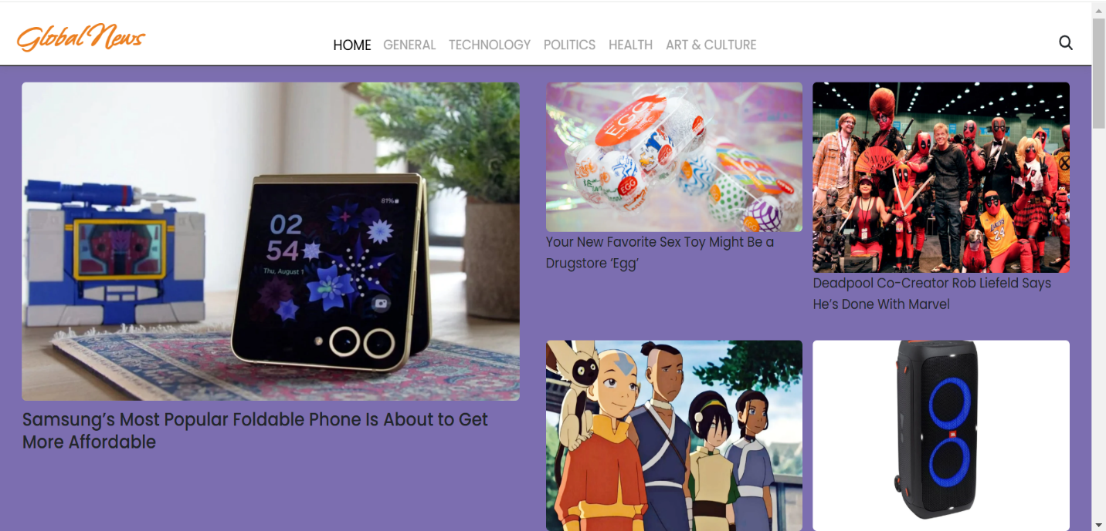**1.Hero components:** In the hero component, the trending news articles are displayed. It is to highlight them. Apart from that, the search bar is also available to search for various articles and categories.

**2.Popular categories:** 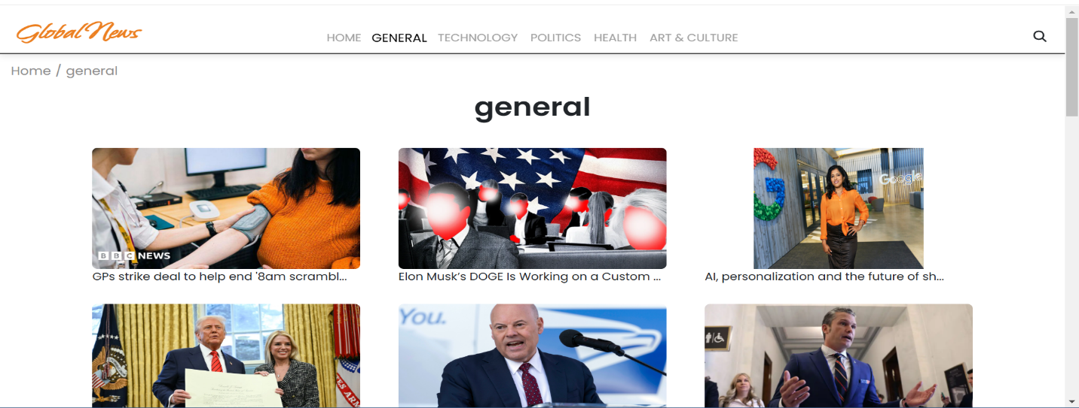In the hero component, the trending news articles are displayed. It is to highlight them. Apart from that, the search bar is also available to search for various articles and categories.

**3.Newsletter**

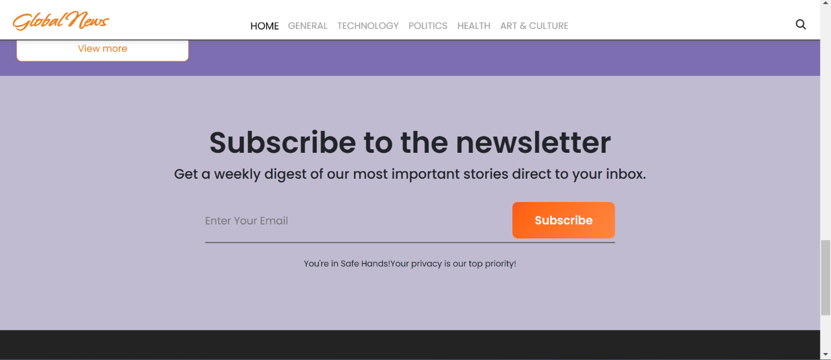Staying informed is key! This section would act as a magnet for users who want to stay up-to-date on the latest news. A brief signup form with an email field would be presented, along with a clear call to action button like "Subscribe Now" . With a simple click, users can join the Global News community and receive accurated news delivered straight to their inbox News Updates.

**4.Category/Search result page**

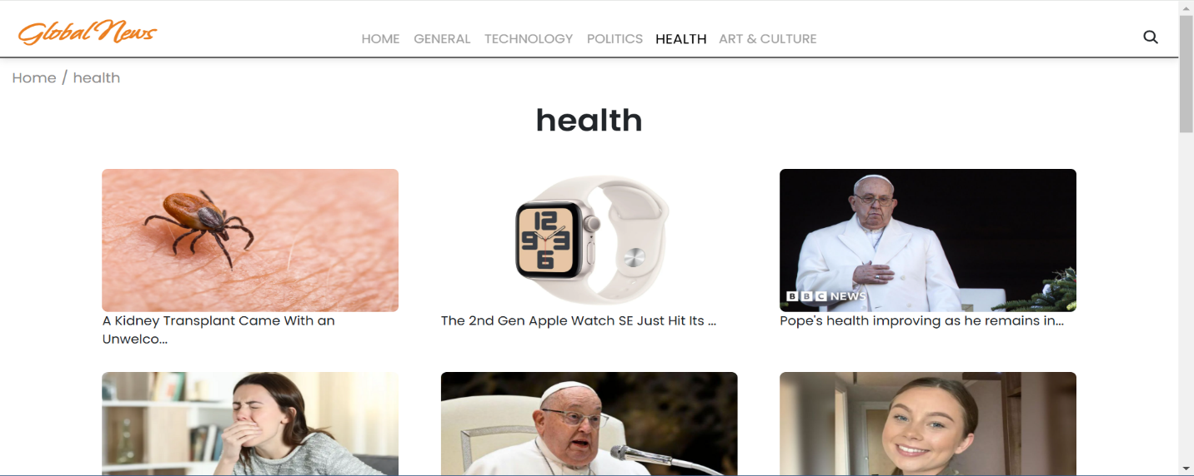Finding the news, you crave is effortless with Global News. This page displays a neatly organized list of articles matching your chosen category or specific search query. Each entry would provide a clear headline, a concise summary, and if available, an image to give you a quick glimpse into the story.

**5.Redirected Article Page:**

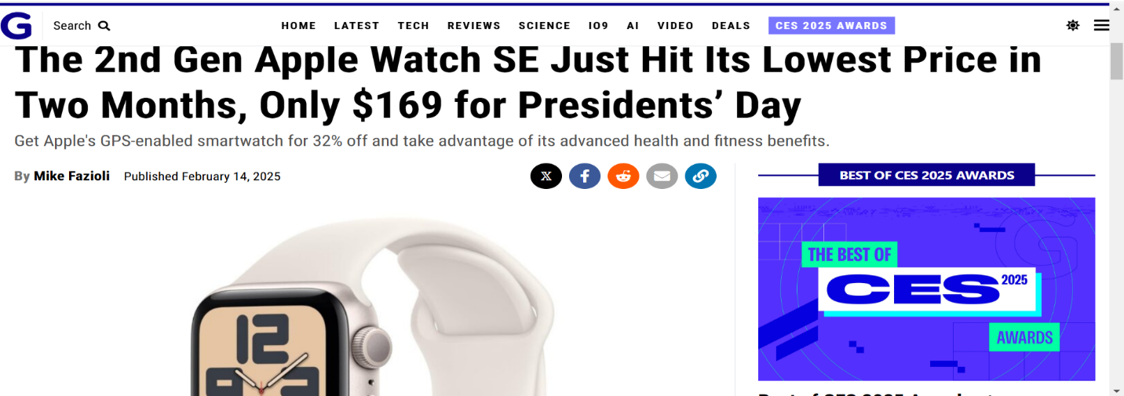This is where you dive deep! The article page proudly displays the complete news story, retrieved directly from the original source. To keep you engaged and exploring related topics, the page might also suggest additional articles based on the current story.

**Project Demo Video Link:**

<https://drive.google.com/file/d/1U3T2iSl06mxz4iRI7HOfNQDWtUZwEwB_/view?usp=sharing>

**Use the Code Repository**:<https://drive.google.com/file/d/1-QEM0y-uPGzgoMN-cR8vyyMoqWmlHUQ8/view?usp=sharing>

**13.KNOWN ISSUES:**

* Some API endpoints occasionally fail to fetch news.
* Image loading delay on slow networks.
* UI improvements needed for better mobile responses

**14.FUTURE ENHANCEMENT:**

* Implement real-time news updates via Web Sockets.
* Add user authentication for personalized news feeds.
* Introduce voice-based search functionality.

*** Thank you!! Happy coding!!***